Final Project

Introduction:

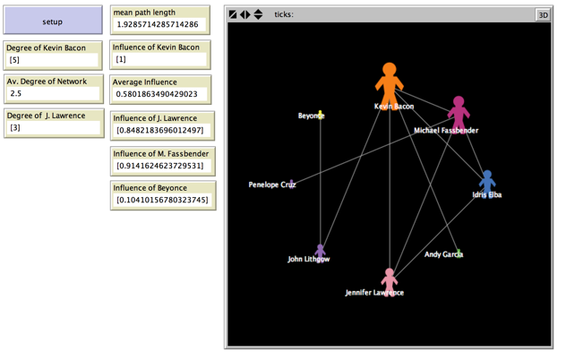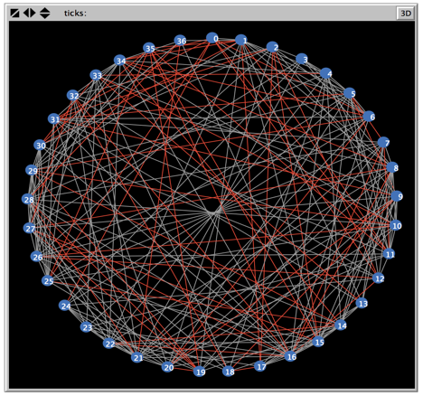For this final project, you will build your own network and run experiments on it by combining techniques introduced in Modules 1—4. You are encouraged to add your own ideas as well.

Project Overview:

We learned about the properties of networks and how to model them. In the final project, you will model a network of your choice and perform some experiments on it. This is a chance for you to be creative and show what you’ve learned.

What should I choose?

How about…

* roads that connect cities in New Mexico
* a food chain
* your own social network
* a network of basketball players where a link exists if they have played on the same team

Project Requirements:

Carefully read the rubric below. You must meet these requirements to gain full points. **You must not use a model from the models library and simply modify it, and your project must not be adapted directly from any of the walkthroughs.** If you want to add different monitors, plots, or have more nodes and edges, go for it! HAVE FUN!

|  |  |  |
| --- | --- | --- |
|  | 40 total | Module 5: Final Project |
|  | **5** | Your file is named correctly *lastname.networksfinal.nlogo* **(1)**, includes the networks extension **(1)** and has extensive inline comments **(3)**. |
|  | **10** | Your Info Tab is complete. It is clear from what you have written in the Info Tab what you modeled and why you chose to model it. |
|  | **5** | Your project uses *at least* one foreach loop. |
|  | **3** | Your graph has *at least* 10 nodes and *at least* 11 edges (*at least* one node has degree >= 2). |
|  | **10** | Create an experiment using Behavior Space **(5)** and clearly explain it in the Info Tab **(5).** |
|  | **5** | Create a table using your Behavior Space experiment, and make a graph from the table. |
|  | **2** | Your interface has *at least* 2 additional features that reveal a property of the network, such as monitors or plots. |
|  | **UP TO 5**  **POINTS EXTRA CREDIT** | You have done additional experiments, created and used your own input file, cleverly used monitors, or have done some additional work that demonstrates extra effort on the project. |